**CGPA to Percentage Calculator using Tkinter Python**

## What is CGPA?

Cumulative Grade Point Average (CGPA) is a grading system used in education to evaluate a student’s academic performance. It represents the average grade points obtained in courses and is often on a scale of 0 to 10. A higher CGPA reflects better academic achievement.

## Aggregate CGPA to Percentage

Apart from individual subject CGPA, there’s also the concept of aggregate CGPA. The aggregate CGPA represents the overall performance across all subjects. To calculate the aggregate percentage, follow the same formula using the aggregate CGPA.

## Benefits of CGPA to Percentage Conversion

* **Comparison**: Converting CGPA to percentage allows easy comparison with percentage-based systems.
* **Job Applications**: Many job applications require percentage scores, so knowing your equivalent percentage is essential.
* **Scholarships and Admissions**: Some scholarships and universities have specific percentage criteria.

## What is Percentage?

Percentage measures relative value, expressing a part of a whole in terms of 100. In academics, it represents the proportion of marks obtained compared to the maximum possible marks. It is widely used to evaluate and communicate performance, often on a scale from 0 to 100%.

## The formula used in CGPA to Percentage Converter.

The CGPA to Percentage conversion formula is very basic. It multiplies the CGPA by a scale (typically 9.5 for a 10-point scale) to obtain the percentage.

**The formula is:**

Percentage = CGPA × Conversion Factor (usually 9.5)

**Example:**

Suppose a student has a CGPA of 8.6 on a scale of 10. To convert this CGPA to a percentage:

Percentage = CGPA × Conversion Factor (usually 9.5)

Percentage = 8.6 × 9.5

Calculating this, we get: Percentage = 81.7%

Therefore, the equivalent percentage for a CGPA of 8.6 is 81.7%.

Suppose a student has a CGPA of 4 on a scale of 5. To convert this CGPA to a percentage:

Percentage = CGPA /5 * 100

Percentage = 4/5 *100

Percentage = 80%

Calculating this, we get: Percentage = 80.%

Therefore, the equivalent percentage for a CGPA of 4 is 80%.

Please take note of the following text:

1. 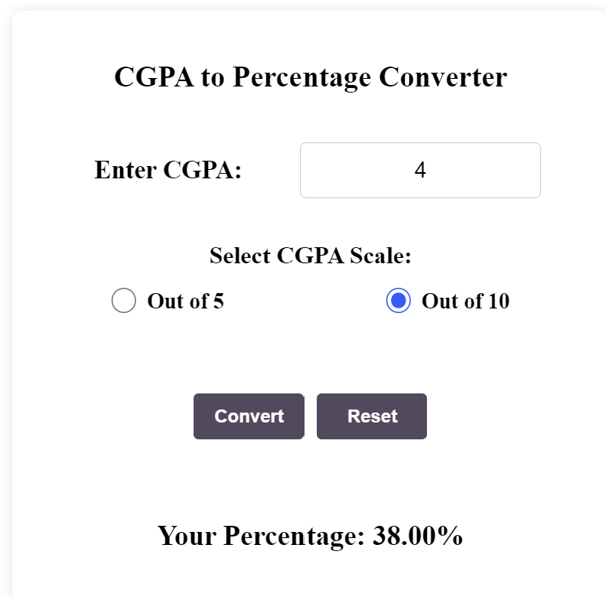Create the GUI screen as shown in the picture below.
2. Use the place method to position all the widgets based on the screen dimensions.

           For instance:

           cgpa_label = ttk.Label(cgpa_frame, text="Enter CGPA:") cgpa_label.place(x=200, y=100)

1. To create the radiobutton use the below code.

scale_10_button = ttk.Radiobutton(cgpa_frame, text="Out of 10", variable=scale_var, value="10")

         scale_10_button.place(x=200, y=150)

1. Refer Your BMI calculator code and create similarly.